**Experiment 9: Water Purification: Hardness Estimation by EDTA method and its Removal using Ion-exchange Resin**

**Experimental values for the following students:**

**Titration-I: Standardization of EDTA**

Pipette out 20 mL of the standard hard water containing 1mg/mL of CaCO3 (1000 ppm) into a clean conical flask. Add one test tube full of ammonia buffer (NH4OH – NH4Cl) solution to maintain the pH around 10. Add three drops of Eriochrome Black – T (EBT) indicator and titrate it against the given EDTA solution taken in the burette. The end point is change of colour from wine red to steel blue. Repeat the titration for concordant titer values. Let ‘V1’ be the volume of EDTA consumed.

|  |  |  |  |  |
| --- | --- | --- | --- | --- |
| **S. No.** | **Volume of standard hard water (mL)** | **Burette reading (mL)** | | **Volume of EDTA**  **(V1, mL)** |
| **Initial** | **Final** |
| 1 | **20** | **0** | **18.5** | **18.5** |
| 2 | **20** | **0** | **19.0** | **19.0** |
| 3 | **20** | **0** | **18.5** | **18.5** |
| **Concordant titer value** | | | | **18.5** |

**Calculation:**

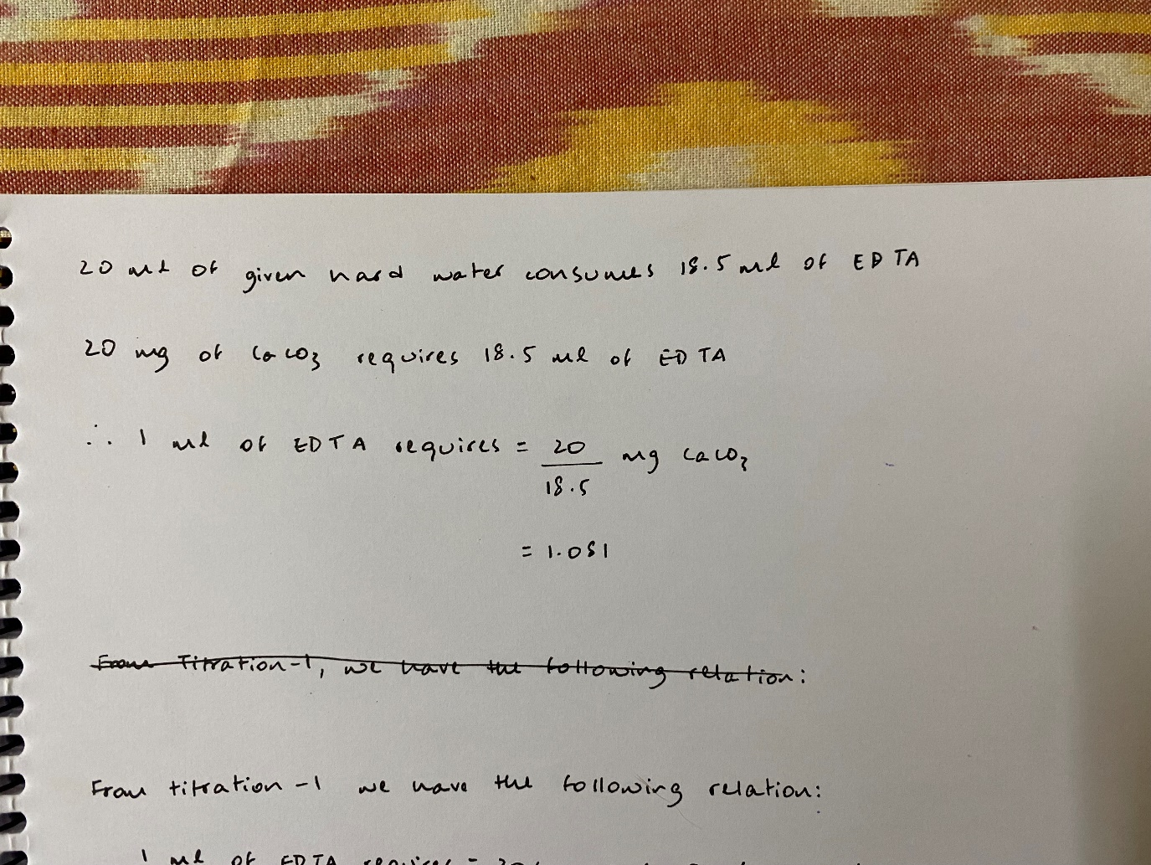

***This relation will be used in other two titrations***

**Titration-II: Estimation of total hardness of hard water sample**

Pipette out 20 mL of the given sample of hard water into a clean conical flask. Add one test tube full of ammonia buffer (NH4OH – NH4Cl) solution and three drops of Eriochrome Black–T (EBT) indicator. Titrate this mixture against standardized EDTA solution taken in the burette. The end point is the change of color from wine red to steel blue. Repeat the titration for concordant titer value. Let ‘V2’ be the volume of EDTA consumed.

|  |  |  |  |  |
| --- | --- | --- | --- | --- |
| **S. No.** | **Volume of sample hard water (mL)** | **Burette reading (mL)** | | **Volume of EDTA**  **(V2, mL)** |
| **Initial** | **Final** |
| 1 | **20** | **0** | **15.0** | **15.0** |
| 2 | **20** | **0** | **15.0** | **15.0** |
| 3 | **20** | **0** | **14.5** | **14.5** |
| **Concordant titer value** | | | | **15.0** |

**Calculation:**

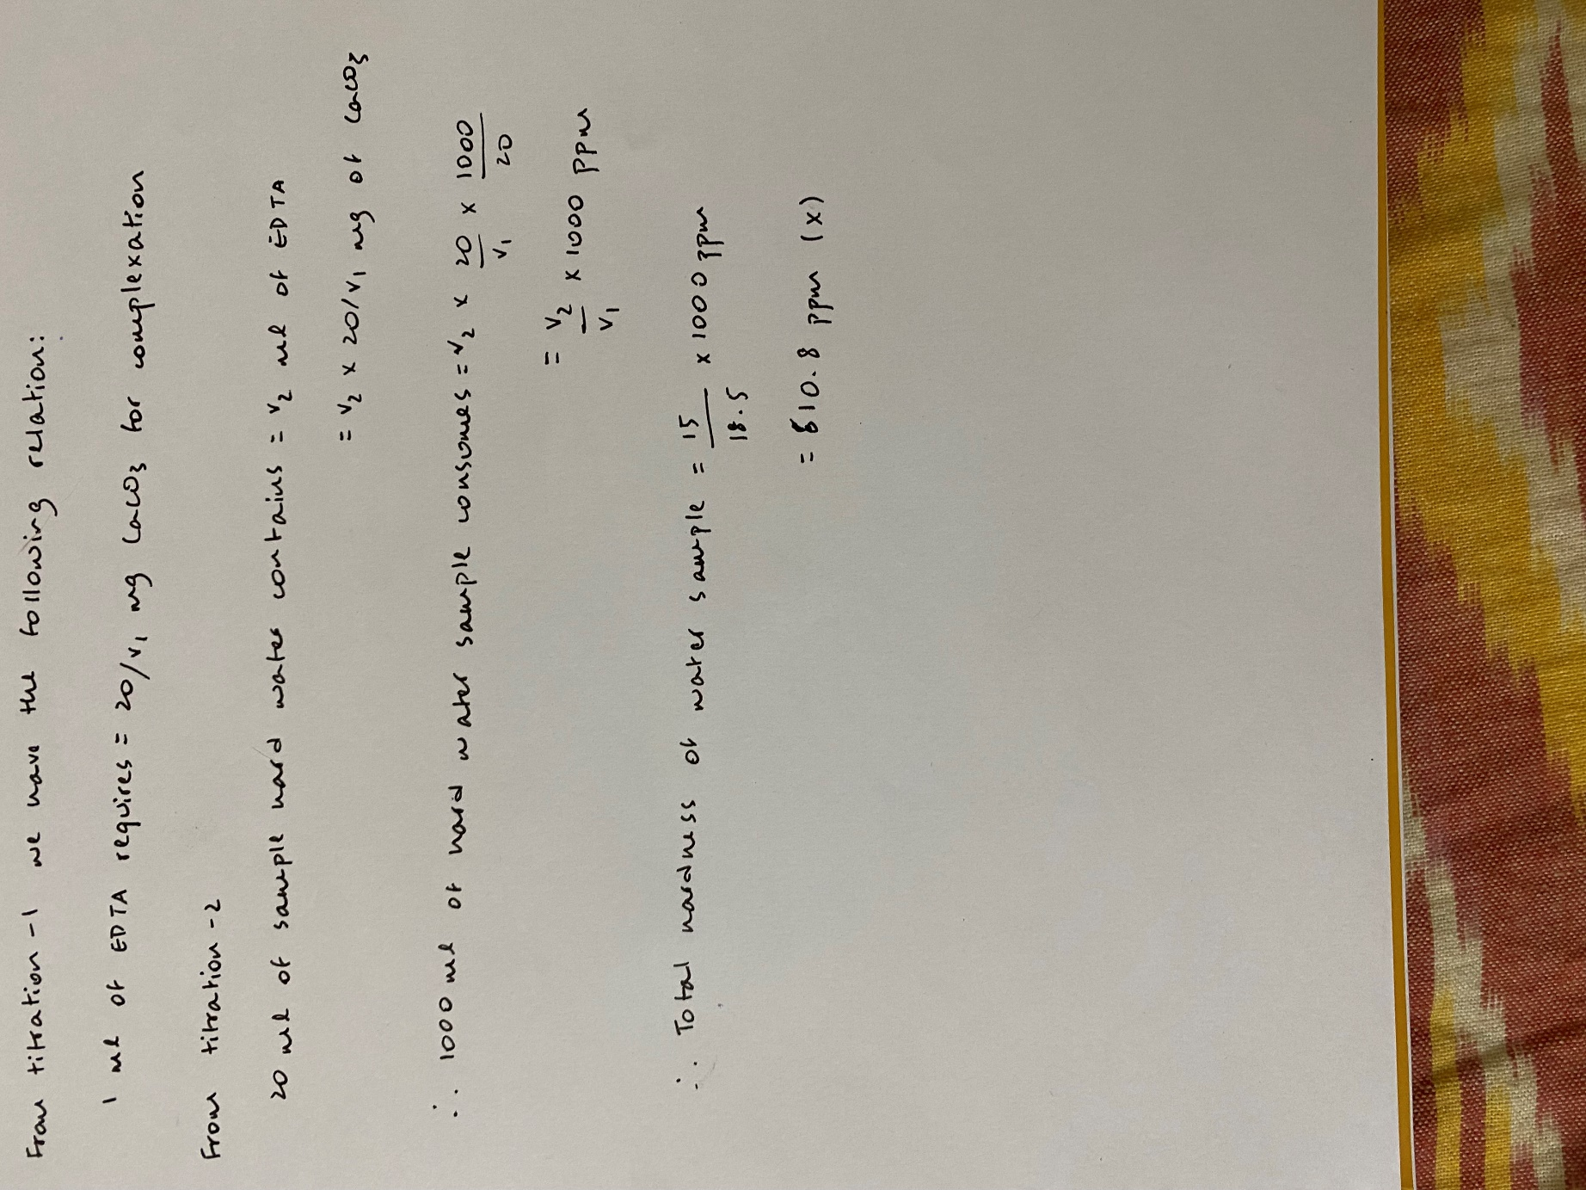

**Titration-3: Removal of hardness using ion exchange method**

Arrange the ion exchange column on to a burette stand and place a clean funnel on top of the column. Pour the hard water sample (around 40 to 50 mL) remaining after the completion of Titration – 2 through the funnel and into the ion exchange column. Place a clean beaker under the column and collect the waterpassing through the column over a period of 10minutes. Adjust the valve of the column to match the duration of outflow.

From the water collected through the column, pipette out 20 mL into a clean conical flask and repeat the EDTA titration as carried out above. Note down the volume of EDTA consumed as ‘V3’.

**Calculation:**

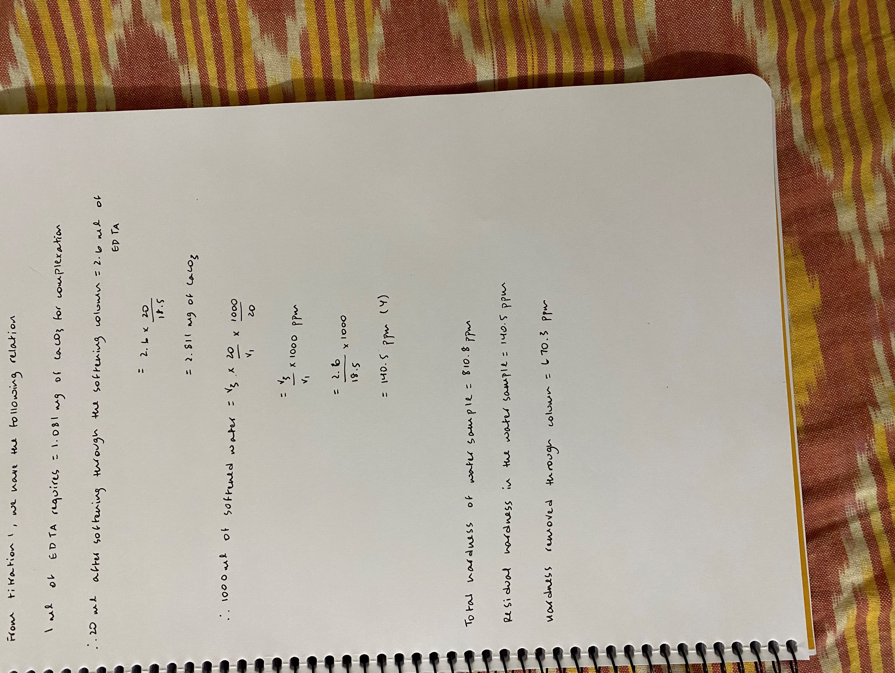

|  |  |  |  |  |
| --- | --- | --- | --- | --- |
| **S. No.** | **Volume of sample hard water (mL)** | **Burette reading (mL)** | | **Volume of EDTA**  **(V3, mL)** |
| **Initial** | **Final** |
| 1 | **20** | **0** | **3** | **3** |
| 2 | **20** | **0** | **2.6** | **2.6** |
| 3 | **20** | **0** | **2.6** | **2.6** |
| **Concordant titer value** | | | | **2.6** |

**Result:**

